**Name:-Tushar J Shukla**

**Roll no.16010422272**

**Batch:-C-2**

**Layout of the WeatherMe Website on Figma**

**Welcome Page:-This Page Welcomes the user and ask him to Login or Sign up**

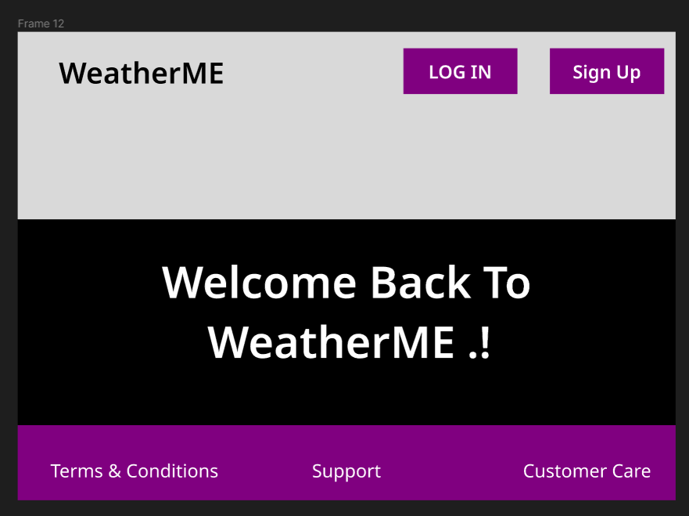

**Today Page:-This Page shows today’s weather**

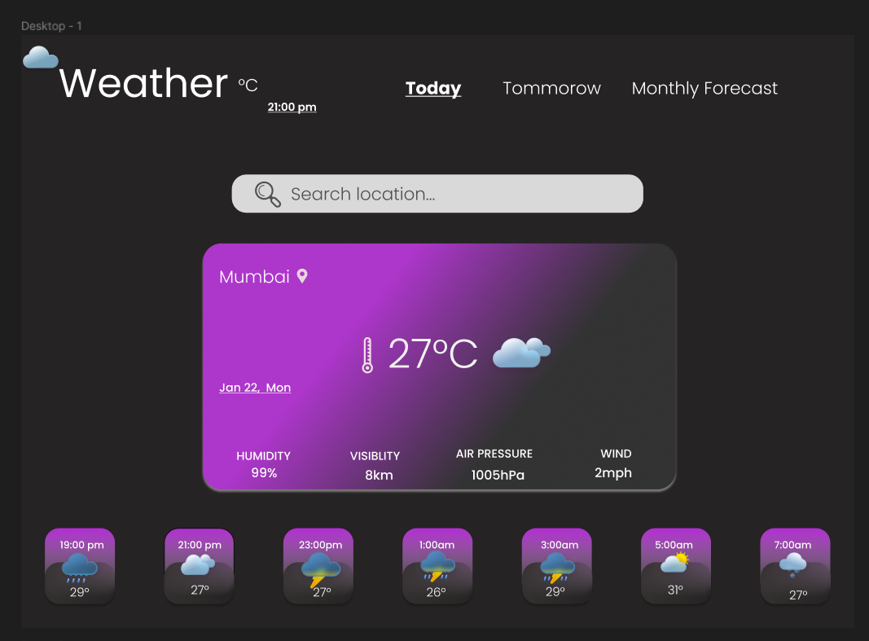

**Tomorrow Page:-This Page shows Tomorrow weather**

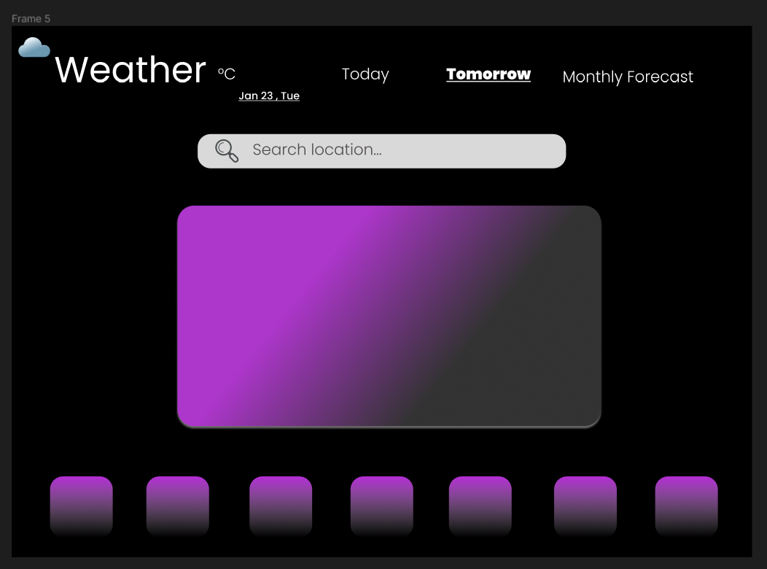

**Monthly Page:-This Page shows Monthly weather**

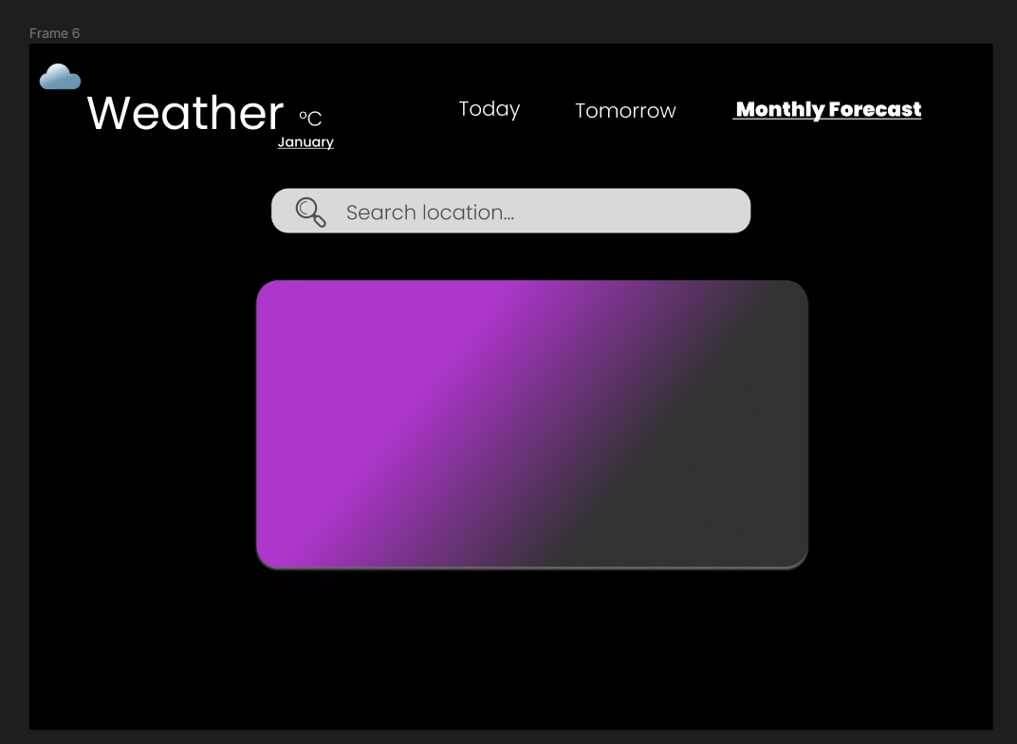

**Serach Page:-This Page can be used to Search for specific city**

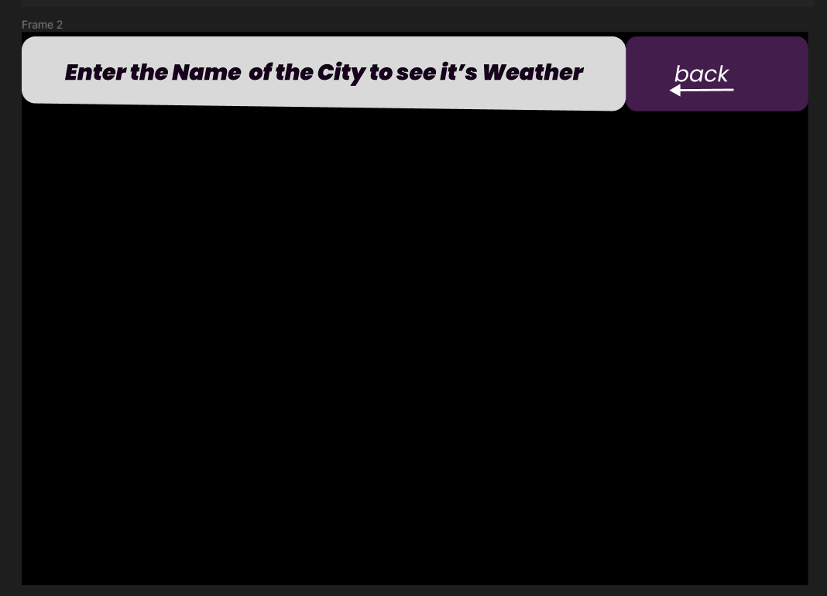

**Login Page:-This Page provides Login interface for the user**

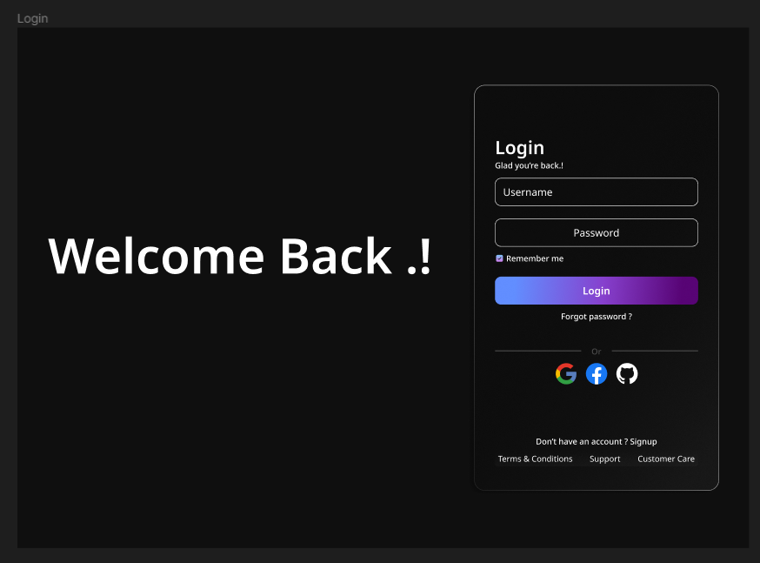

**Sign Up Page:-This Page provides Sign up interface for the user**

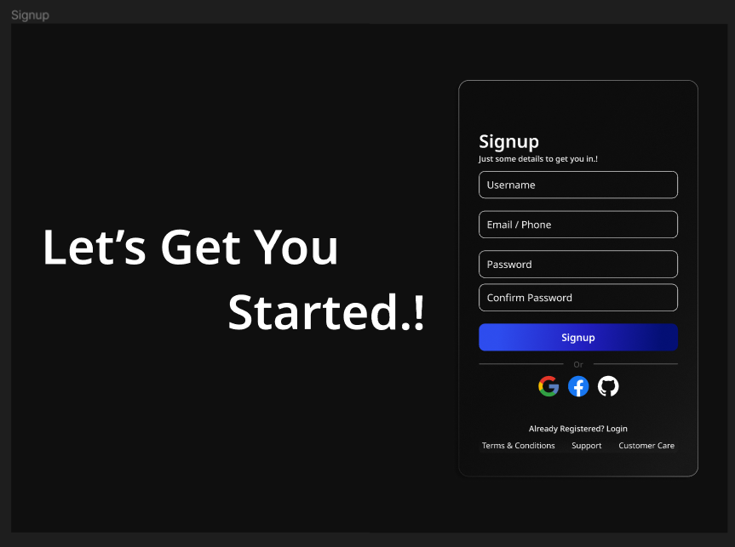

**Forgot Password Page:-This Page provides Forgot Password interface for the user**

